Published 5th October 2016

Enterprise Mode Site List Manager

Self Service Portal

Scenario Guide

*Topic Tag: EnterpriseMode; EMIE; EniterpriseModeSiteList; Self-Service; Self-service portal; portal;*

*Key Contacts: Michael Munch (mmunch)*

**Summary**: This document describes the various aspects of Enterprise Mode Site List Manager tool helps create and manage the Enterprise Mode Site List in the v.1 and v.2 XML schema for Enterprise Mode.

Contents

1. Overview 1

2. EMIE Self Service Portal 1

3. Required Hardware 2

4. Required Software 2

5. Tool Deployment 3

6. Risks 3

7. Role Based Operations (Requester, Approver & EMIE Champion) 3

Requester Role 3

Approval Role 9

EMIE Champion Role 10

8. Reports 23

9. Site List Manager Tool 25

10. View Site List 28

11. Troubleshooting 28

12. Additional Material 28

# Overview

Enterprise Mode is a compatibility mode that runs applications on IE, letting websites render using a modified browser configuration, avoiding the common compatibility problems associated with them. Also, any website that is not compatible with Microsoft Edge, can be redirected and rendered in IE using the best browser configuration.

The objective of this portal is to govern the process of EMIE Site List Management so as to maintain site list accuracy, and ensure necessary checks, approvals to be acquired, before any changes are made. The automated push to production will help avoid human errors.

Many organizations identify web app compatibility as a significant cost to upgrading because web apps need to be tested and upgraded before adopting a new browser. The improved compatibility provided by Enterprise Mode can help give organizations confidence to upgrade to the latest version of IE. In particular, IE11 lets customers benefit from modern web standards, increased performance, improved security, and better reliability.

# EMIE Self Service Portal

The EMIE Self Service Portal is a web based application, that helps enterprise:

* Manage EMIE Site lists from any device supporting Windows 7 or greater
* Supports Change Requests for site listing
* An On-Premise solution, works with no internet connection
* Provides a role based governance model for maintaining site listings
* Test the configuration settings before releasing to a live environment
* Provides a client tool to ease the creation and management, ideal for smaller lists

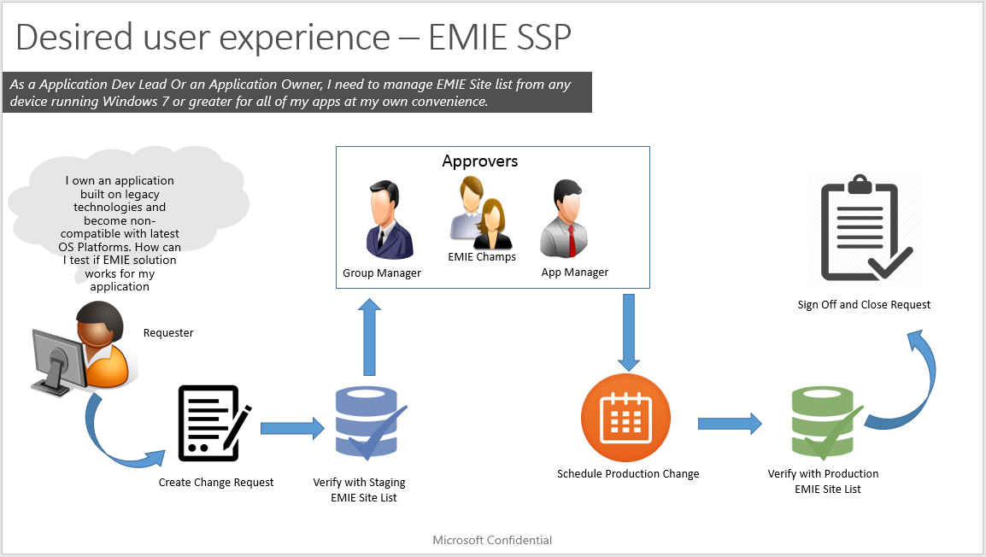

# Required Hardware

This scenario requires the following hardware or hardware features for successful completion:

|  |  |
| --- | --- |
| Hardware | Description |
| Minimum Physical Memory | 16 GB RAM recommended |
| Available disk space | The PC must have at least 8GB of free space. Disk must be formatted by NTFS file system for better security |

# Required Software

This scenario requires the following software or software features for successful completion:

|  |  |
| --- | --- |
| Software | Minimum Version |
| Client Operating System | Windows 7 or higher |
| Active Directory | Domain joined |
| Additional Server Infrastructure | Internet Information Service (IIS) 6.0 |

# Tool Deployment

EMIE Champion: Please refer the following attached document for tool deployment in an enterprise.



# Risks

None identified.

# Role Based Operations (Requester, Approver & EMIE Champion)

# Requester Role

The user of EMIE SSP with Requester role will be able to perform following operations:

* Create Request, validate site with pre-production environment, rollback in case of failure, send request for approval.
* View requests created by himself
* Trigger a production change on request approval
* Sign off request and close

## UC1: Creating a change request and sending it for approval.

1. User logs in to the web portal having requester role, lands on create request page, starts creating a change request with details.
2. After filling in details, user clicks on [Save and Proceed Button]
3. A success message with CR #ID will be generated, site entry will be made to pre-production EMIE Site and Email notification will be sent with next steps.

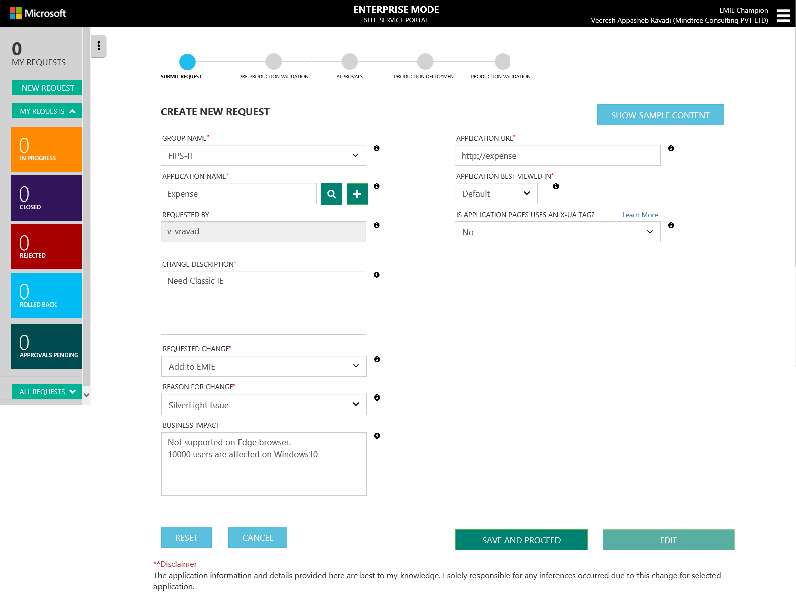

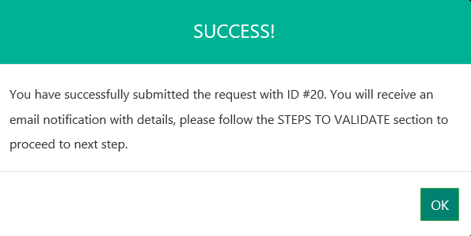

1. Then user will have to sets up a test machine to verify the application with EMIE pre-production environment, and update the change request with Verification. The detailed steps for verification and batch script for configuration will be sent through an email notification when request is submitted.
2. If validation passes, then requester can send the change request for approval by selecting **Successful** radio button and clicking on **Send For Approval**.

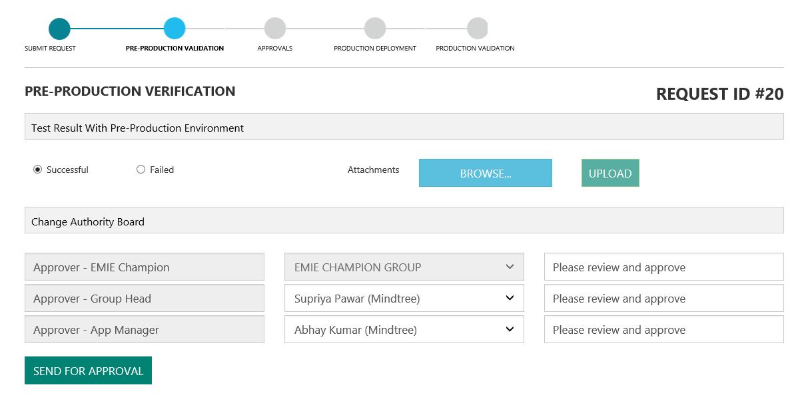

1. If fails, user can self-rollback changes on pre-production OR asks help from EMIE Champs.

[Selects **Failed** radio button, **ROLLBACK** and **SEND FAILURE DETAILS** buttons will be enabled.]

1. User can navigate successfully to each status of the ticket using the workflow links provided on the top (Reference below).



## UC2: With all approvals, requester will go ahead selecting Prod changes schedule.

1. User sees all approvals for his requests.

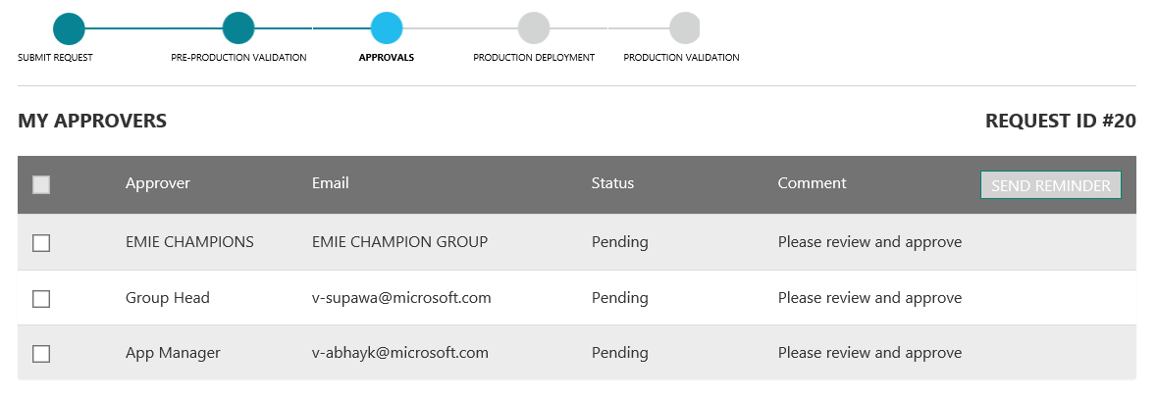

Need to change the following screenshot

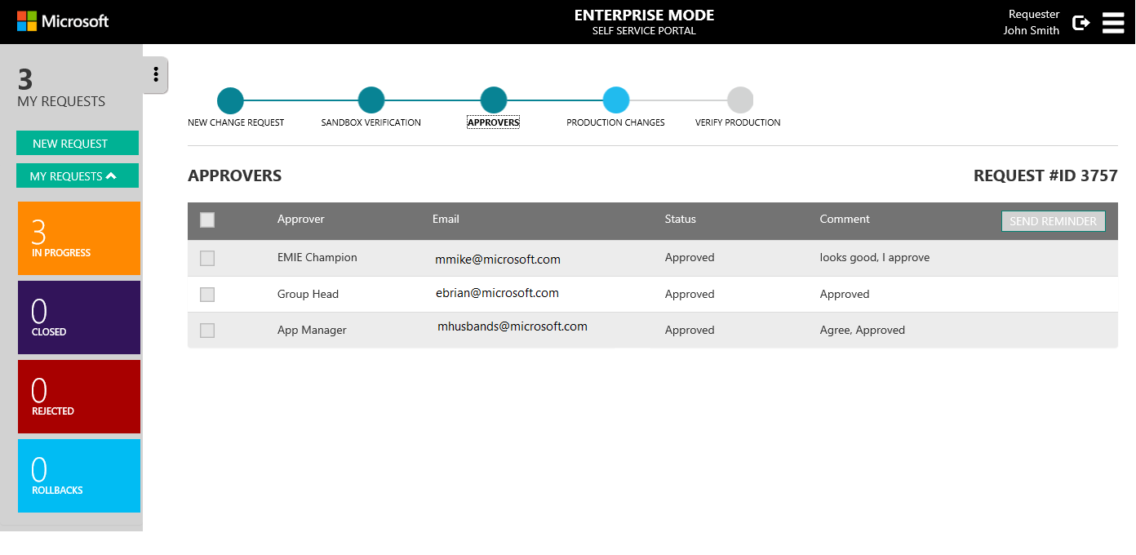

1. On all approvals, requester will navigate to **PRODUCTION CHANGES** to schedule the live change dates.
2. Request can either choose to make the production changes **NOW** or for the future dates.
3. To make the changes NOW, select the **NOW** checkbox and click Save.

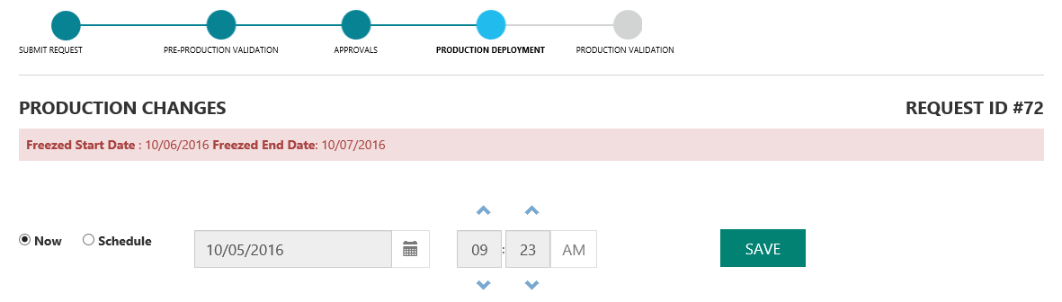

1. To schedule for the future dates, select the **SCHEDULE** check box and choose the appropriate date and time period. Click Save.

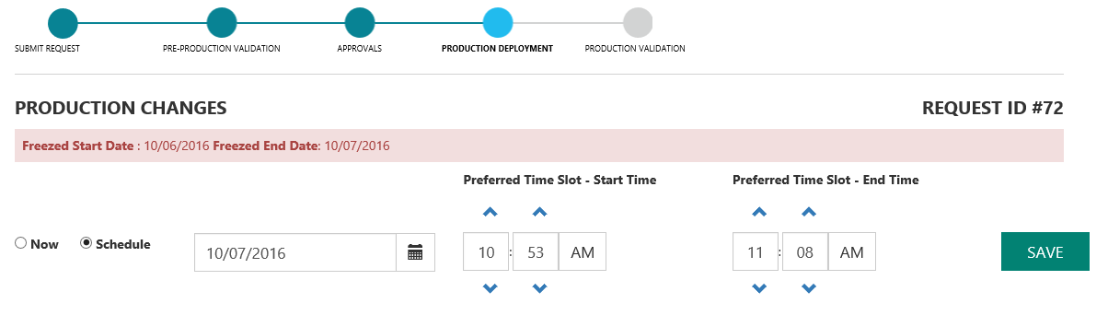

1. After Go-Live date and Production Change happened, verifies with Production environment. (Manual verification)
2. On Success Signs Off. [SUCCESS Radio with Sign Off enabled.]

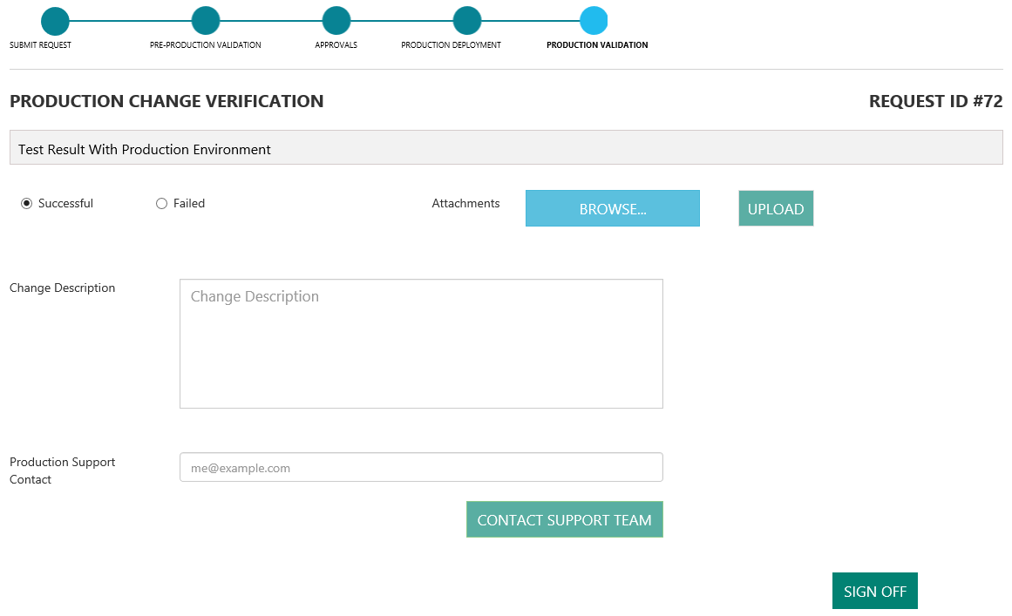

1. On Failure, notifies EMIE Admin for help. [FAILED Radio with GET HELP enabled.]

## UC3: Follow up- Sends Reminder for approval.

1. Send reminder for approvers. [Clicks on SEND REMINDER button]

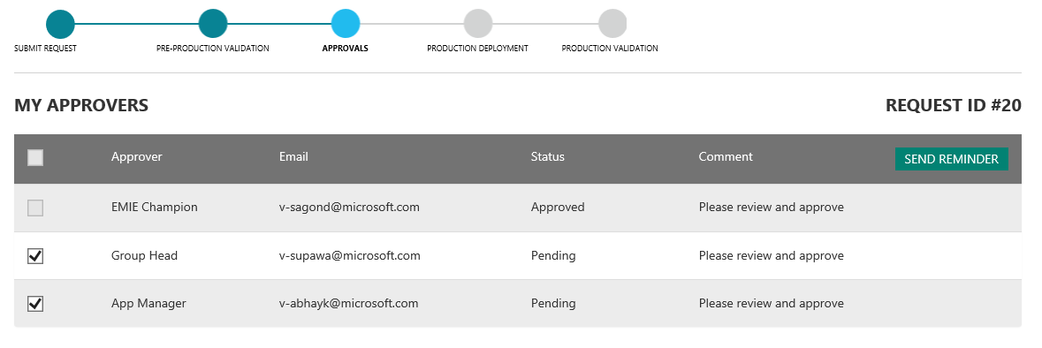

# Approval Role

The user of EMIE SSP with Group Manager role will be able to perform following operations:

* Approve requests coming on his way within owned group
* Create Request, validate site with pre-production environment, rollback in case of failure, send request for approval.
* View requests created by himself
* Trigger a production change on request approval
* Sign off request and close

## UC4: Approver approved the change request.

1. User logs the change request and send it for approval.
2. An email will be triggered to the Approvers, requesting approval for the change request.
3. Approver logs in to the web portal lands on to the Approvals page or can be navigated to **APPROVALS PENDING** page using side menu links.

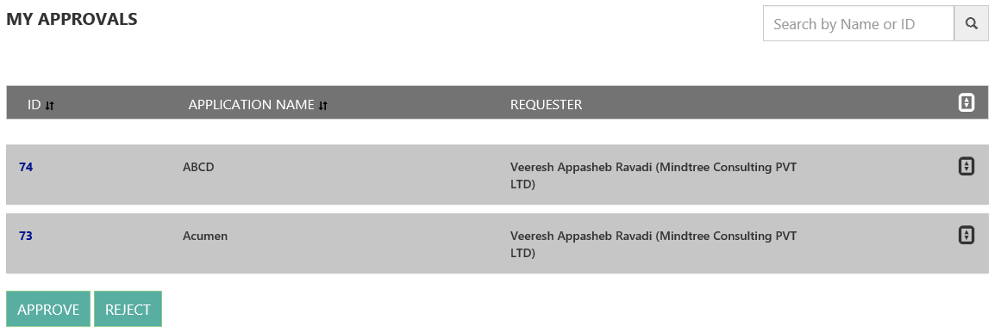

1. Approver selects individual ticket ID’s and verifies the information provided in the change request ticket.

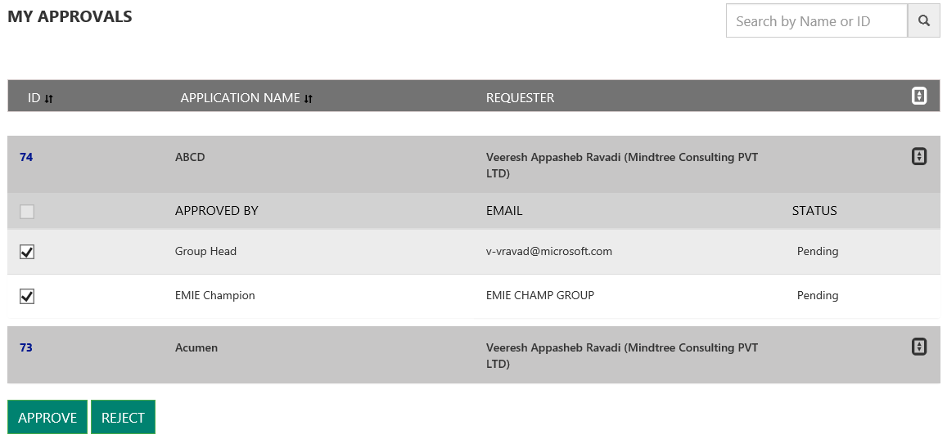

1. Approver **Approves** or **Rejects** the individual tickets depending the information provided.
2. A Success message will be displayed after the ticket is Approved.

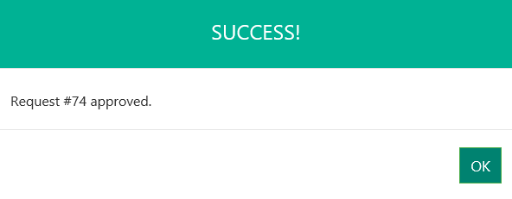

1. An email will be triggered to Requester, Approver and EMIE Champion with the status of the ticket.
2. Approver can also navigate to other side menu links **IN PROGRESS**, **CLOSED**, **ROLLBACKS** requests status of respective Group that approver belongs.

# EMIE Champion Role

The user of EMIE SSP with Requester role will be able to perform following operations:

* Approve request
* Create Request, validate site with pre-production environment, rollback in case of failure, send request for approval.
* View requests created by himself
* Trigger a production change on request approval
* Sign off request and close
* User Management: Add User, Assign roles, approve registrations
* Settings: Set Freeze Schedule, Set Pre-production, Production XML Site path, Attachment upload location etc.
* Standalone Tool: All features of Standalone tool
* Reports: View all Reports

## UC5: Rolls back changes on Pre-Production on failures and closes request.

1. If the verification fails on the pre-production, user can report the issue details on portal.
2. Under Pre-Production verification page, select the FAILED checkbox.
3. Attach the issue snapshots or any supportive docs and mention the issue details.
4. Click on Send Failure Details to send the details to EMIE Champion.
5. Click on Rollback button to roll back the changes in pre-production.
6. Once request is Rolled back on pre-production, requester will be navigating to data entry page.
7. Click on Edit and modify the data fields. Resubmit the ticket by clicking **Save and Proceed.**

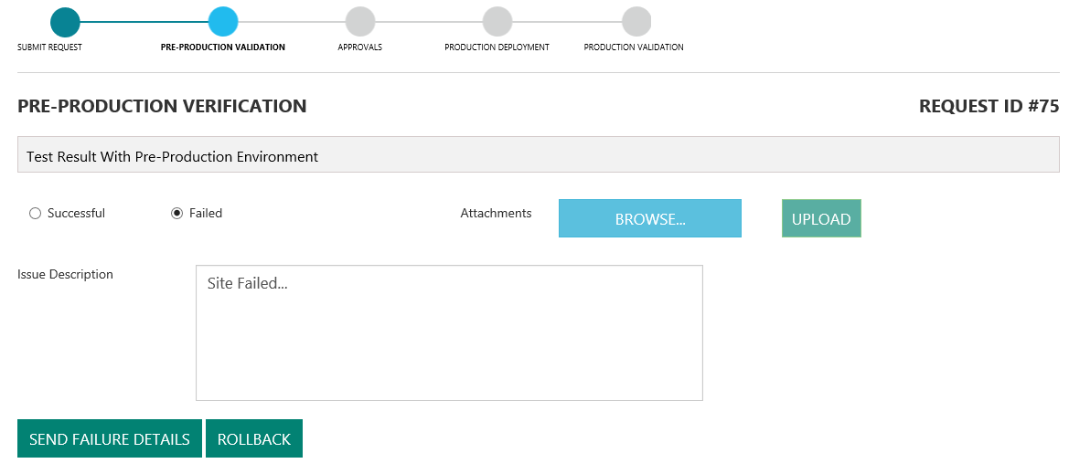

## UC6: Rolls back changes on production on failures and closes request.

1. Once production changes have been made a mail will be triggered to requester asking for SignOff on the ticket.
2. Requester logs into portal and navigates to **VERIFY PRODUCTION** page of the respective ticket.
3. If the verification fails on the PRODCUTION, user can report the issue details on portal.
4. Under **VERFIY PRODUCTION** page, select the **FAILED** checkbox.
5. Attach the issue snapshots or any supportive docs and mention the issue details.
6. Click on Send Failure Details to send the details to EMIE Champion.
7. Click on Rollback button to roll back the changes in production.
8. The entry will be successfully updated in the production EMIE xml.

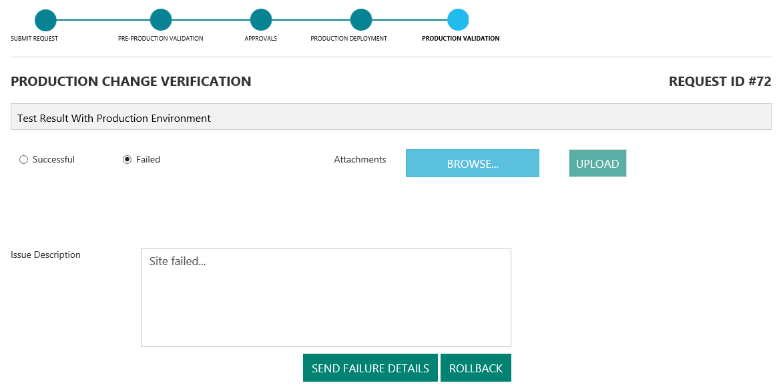

## UC7: Views dashboard, all requests and take actions.

1. User logs in to portal with the EMIE Champion role.
2. Navigates to **APPROVAL PENDING** page.
3. Selects individual ticket ID’s and verifies the information provided in the change request ticket.
4. Approves/Rejects the change request.



1. Navigates to **ALL REQUESTS** page to view current status of the individual ticket using the side Menu links.
2. Individual tickets can be opened using the links provided and validate the details.

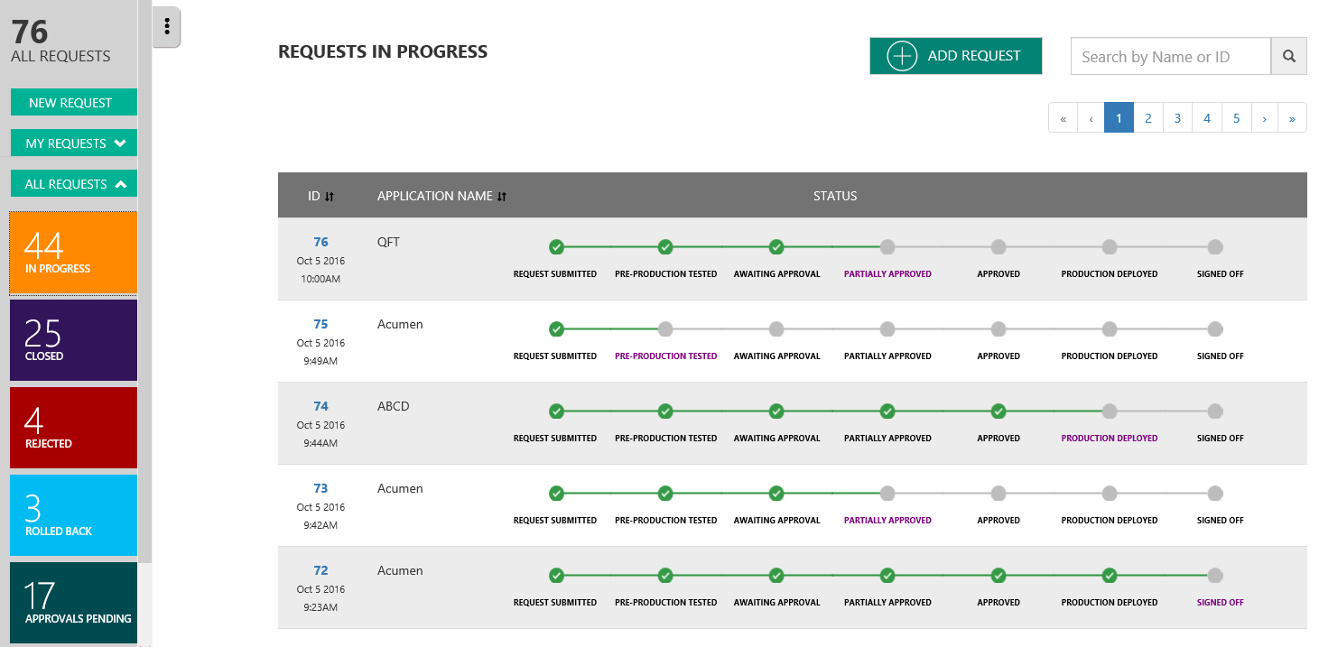

1. Navigates to **ROLLBACKS** to view the tickets got rollback.

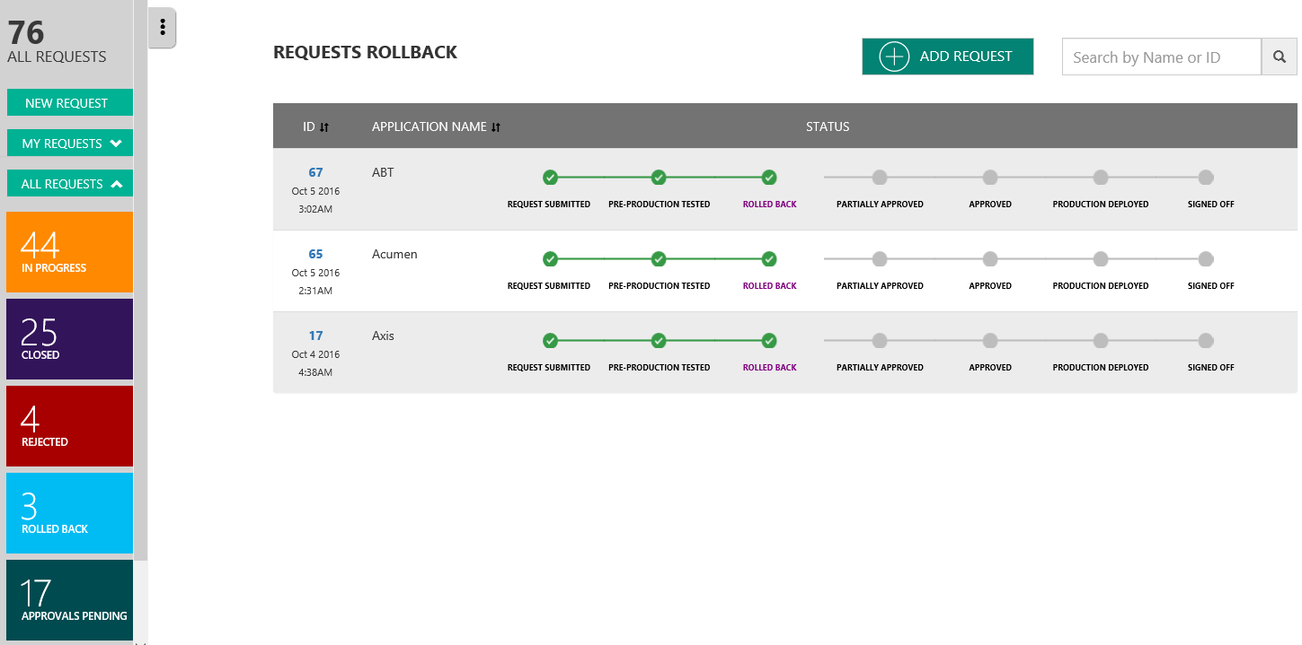

1. Click on the individual tickets and investigate the issue for the change rollback.

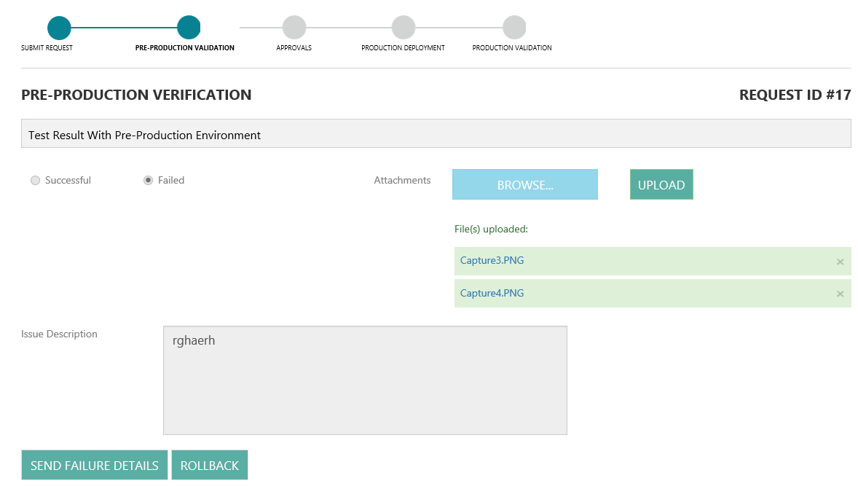

1. EMIE Champion will be able to perform the roles of Requester and Approvers.

## UC8: **USER MANAGEMENT** - Grants access to the portal for users

1. User submits request to access the Web portal, an email will be triggered to EMIE Champion
2. EMIE Champion logs in to portal and navigates to **USER MANAGEMENT** tab via top menu links.

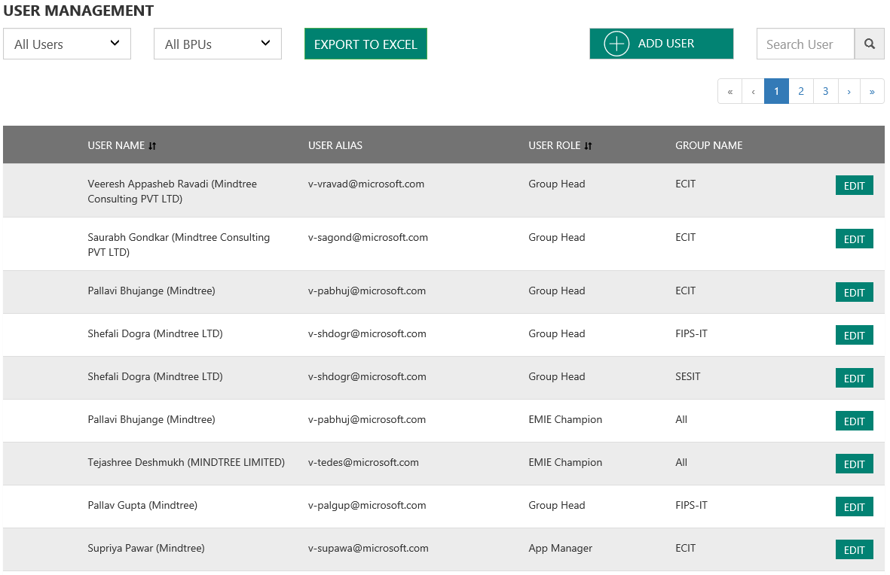

1. Selects the individual user and click on EDIT button.
2. Approves the access request by checking the ACTIVE checkbox and SAVE.

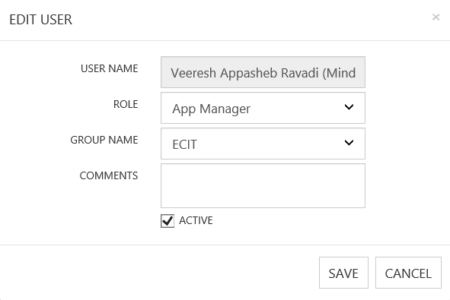

1. EMIE Champion can also add the USER to portal via **ADD USER** feature with appropriate roles assigned.

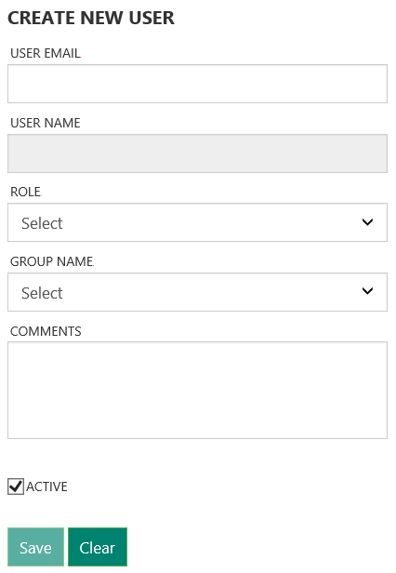

1. EMIE Champion can **ACTIVATE**/**DEACTIVATE** the invalid users by Checking/unchecking the ACTIVE checkbox on edit user page.

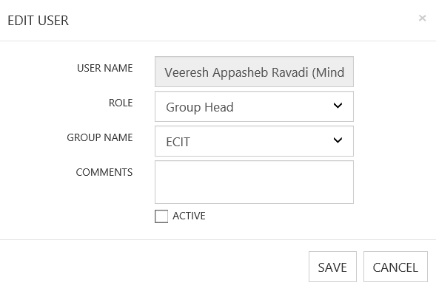

## UC9: **SETTINGS** - Manage the tool configuration settings.

1. EMIE Champion log in to the portal and navigates to **SETTINGS** page via top menu links.

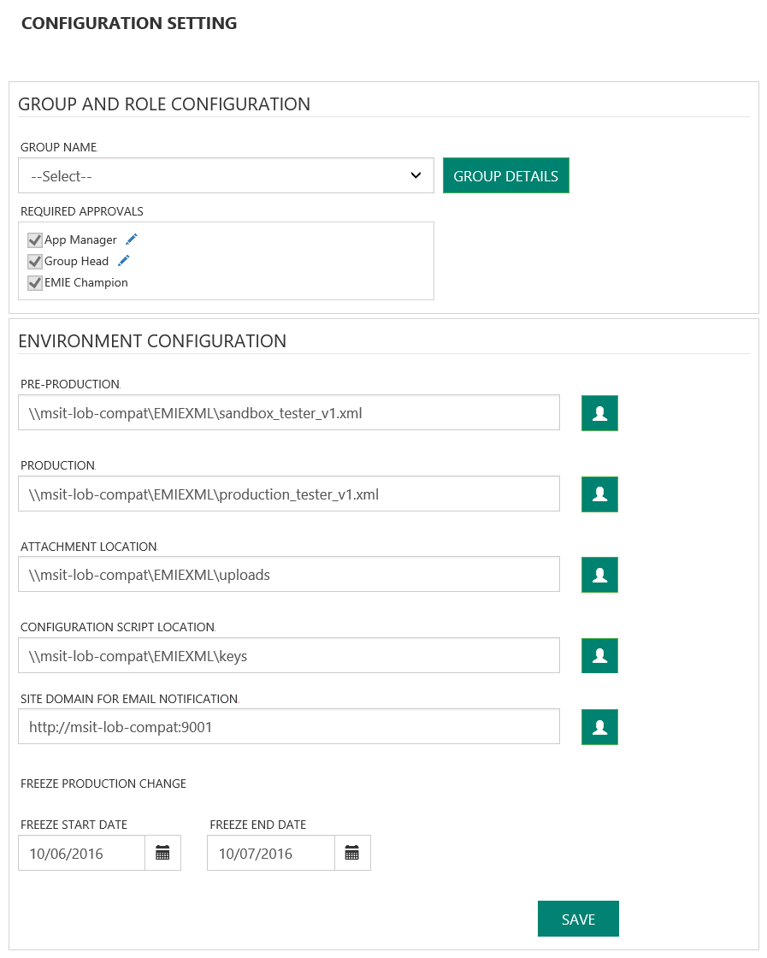

1. EMIE Champion can update the pre-production and production EMIE xml location in the tool by providing appropriate credentials to access the location path.

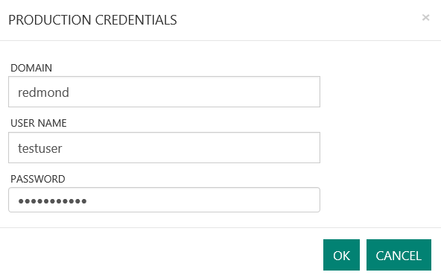

1. Update the attachments file location with appropriate credentials to the path.
2. Update the Freeze Production Change Start and End dates during which no production changes will be made in xml.
3. Can Add the New organization group to the portal by clicking **GROUP DETAILS.**

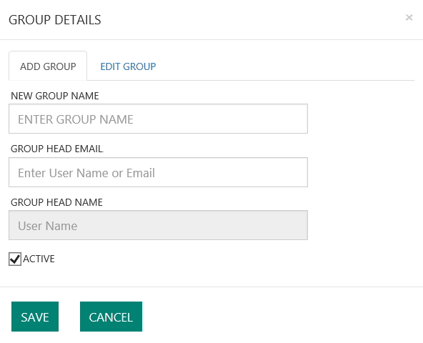

1. Existing group details can be edited by navigating to **GROUP DETAILS**.

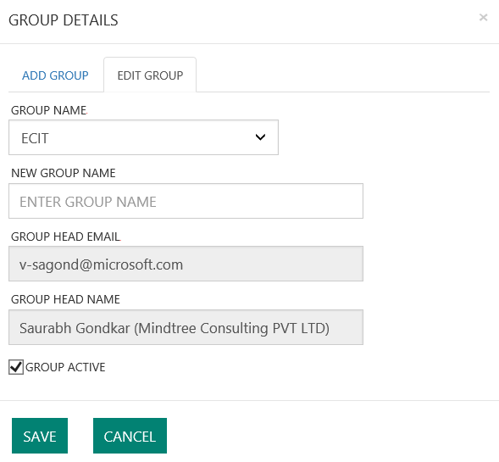

1. Can edit the **GROUP MANAGER** and **APP MANAGER** text labels by clicking on EDIT button.

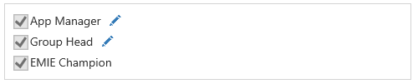

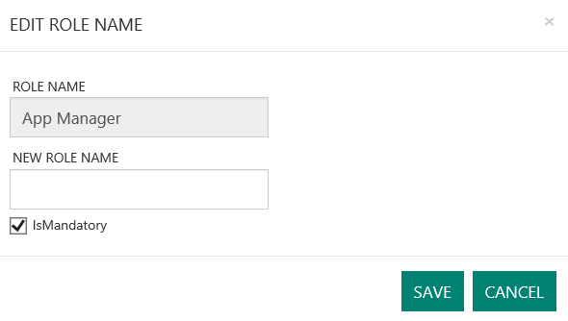

# Reports

## UC10: Users can view Enterprsie Mode Reports dashboard.

1. User log in to the web portal with respective roles.
2. REPORTS page accessible to all the roles Group Manager and EMIE Champion.
3. Navigates to **REPORTS** page via top menu links.

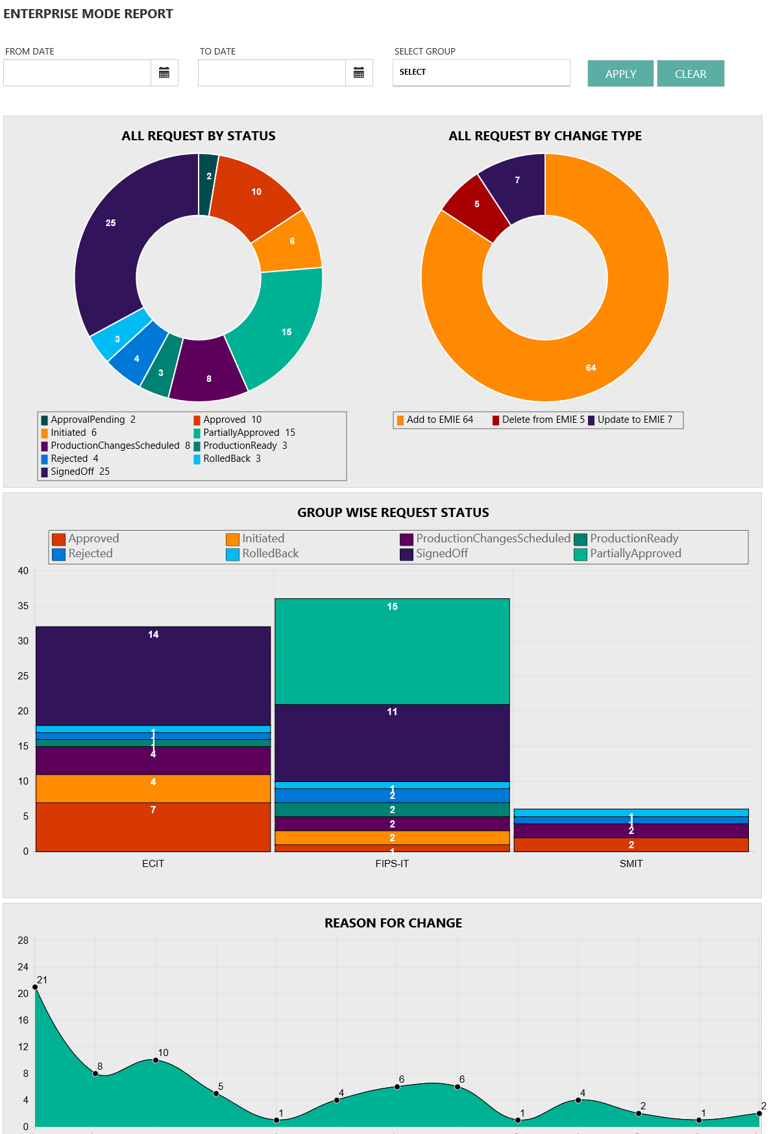

1. User can view the reports for particular date range using the date filters provided on top of the page.
2. User can filter reports according to respective **“GROUP NAME”**
3. REPORTS page has following charts displayed.
   1. **ALL REQUEST STATUS**: Pie chart displays the count of change requests at respective state. (Ex. Approved, Rejected, Signed off)
   2. **ALL REQUEST BY CHANGE TYPE:** Pie chart displays the number requests according to change type. (Add/Remove/Update)
   3. **GROUP WISE REQUEST STATUS:** Displays the change request current status according group wise.
   4. **REASON FOR CHANGE:** Numbers of change requests submitted particular issue type reason.
   5. **SIGNED OFF APPLICATION LIST:** List change requests which made through production change successfully(Added/Removed/Updated) User can sort the application list with “APPLICATION NAME” and “GROUP NAME” alphabetically.

# Site List Manager Tool

This tool helps the EMIE champion to create and update the Enterprise Mode site list, without directly modifying the production EMIE xml. Xml created using this tool will not be saved to EMIE production xml location path. EMIE champion has manually place this production location or append the EMIE entries from xml created by site list manager to existing production xml.

Using site list manager EMIE Champion can perform the following operations.

* Add the site to EMIE Site List.
* Convert V1 EMIE schema to V2 schema and vice versa.
* Bulk add sites existing xml file.
* Merge multiple EMIE xml files and save as one xml file.
* Export the EMIE Site List.
* Import the EMIE Site List.

## UC11: Create and Save EMIE xml using Site List Manager.

1. EMIE Champion logs in to the portal and navigates to **Site List Manager Tool** using the top menu links.

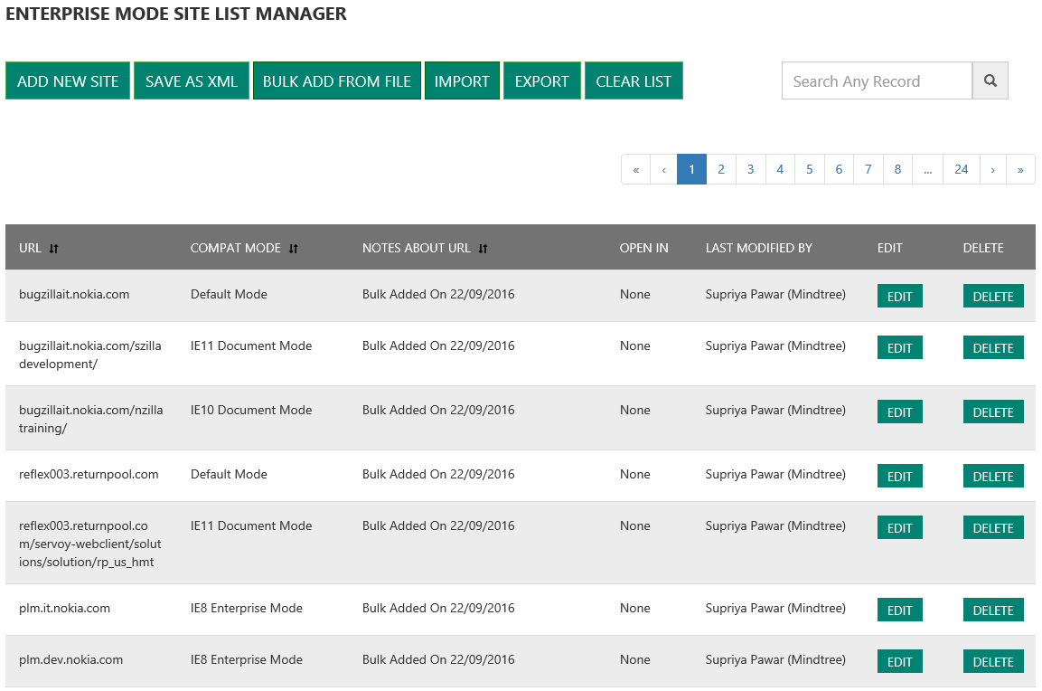

1. Click on **ADD NEW SITE** to add the new sites. Provide the URL/Document Mode and SAVE the details.

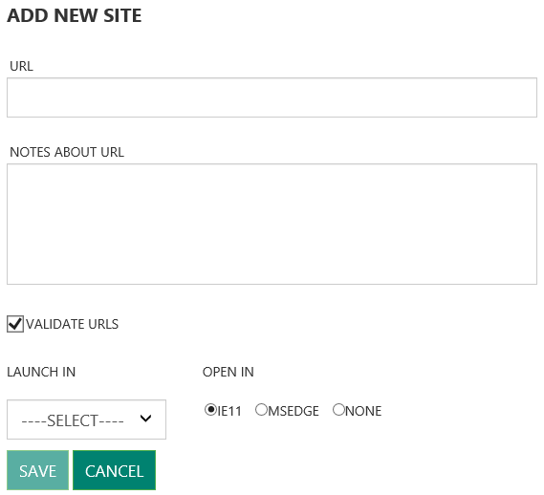

1. After adding all the sites click on **SAVE AS XML.**
2. If there are existing multiple xml files, then all can be merged using the **BULK ADD FROM FILE.**
3. Click on **BULK ADD FROM FILE** and select the xml files to be added then SAVE.
4. **Save As XML** will populate options for saving the xml with V1 schema or V2 schema.

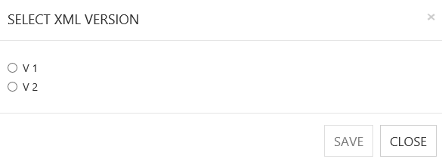

1. It will convert the bulk uploaded xml file schema from V1 to V2 and vice versa as per the requirement.
2. An xml will be downloaded to local machine. These xml entries can be copied to Live EMIE xml.

# View Site List

Review all the websites included in the Enterprise Mode Site List. This list can be viewed by everyone (Requester, Approver, EMIE Champion) who has access to the self-service portal.

User logs into portal and navigates to **VIEW SITE LIST** page using the top menu links. All the entries present in the site list will be displayed in the following format.

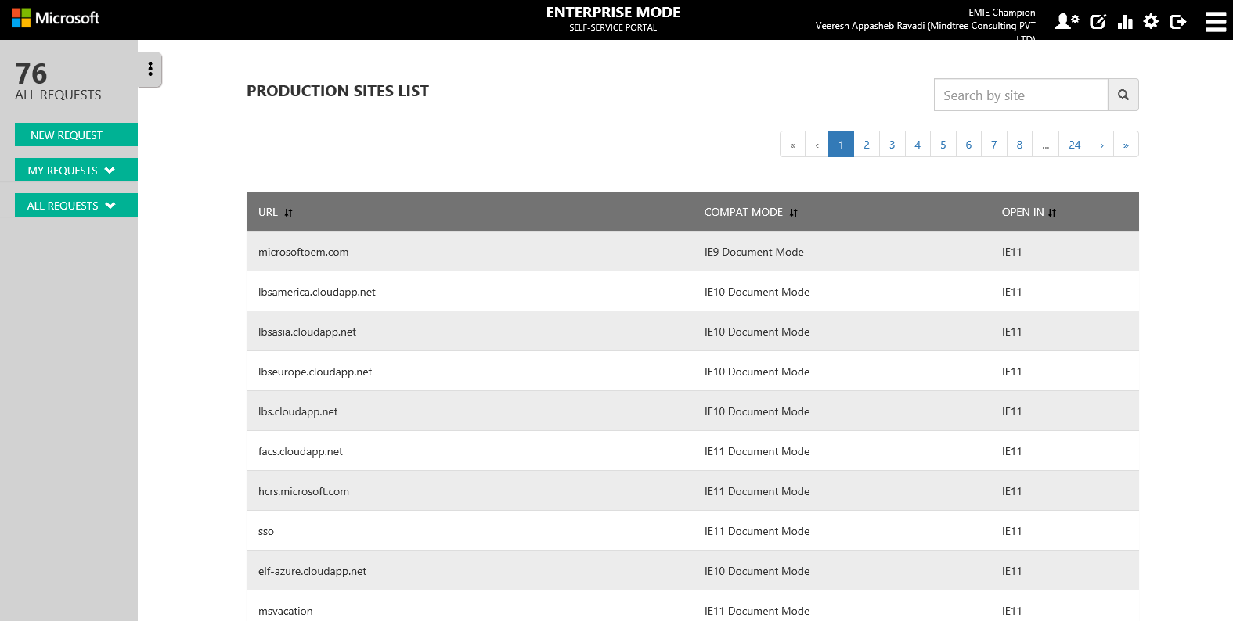

# Troubleshooting

* If XML already exists, check for if it’s syntactically correct
* Update/Delete operation failed, check if EMIE entry already exists in XML
* User is not able to Logs in, account might not have granted access, ask EMIE Champion to Activate your account.

# Additional Material

For more information about Enterprise Mode Site List. How to set up enterprise mode site list for an organization? And how document mode and enterprise mode helps to fix the compatibility issues. Please refer to below reference links.

[Enterprise Mode for Internet Explorer 11](https://technet.microsoft.com/en-us/itpro/internet-explorer/ie11-deploy-guide/enterprise-mode-overview-for-ie11)

[Turn on Enterprise Mode and use a site list](https://technet.microsoft.com/en-us/itpro/internet-explorer/ie11-deploy-guide/turn-on-enterprise-mode-and-use-a-site-list)

[Fix web compatibility issues using document modes and the Enterprise Mode site list](https://technet.microsoft.com/en-us/itpro/internet-explorer/ie11-deploy-guide/fix-compat-issues-with-doc-modes-and-enterprise-mode-site-list)